LE, MY | December 11  2014
IMC PROJECT |  | MARKETING170

Tropical Organic Garden is a new beverage shop specializing on organic smoothies and juices with fresh, natural and quality tropical tastes, made from 100% organic ingredients. According to ABC News, by 2030 more than half of Americans could be obese, causing millions of new cases of diabetes, coronary heart disease, and stroke. In fact, the costs spent for the treatment of obesity disease is estimated around $18 billion per year in 2011. In future, the trend shows about $66 billion per year by 2030, and over $500 billion in lost economic productivity. Nearly two out of every three Americans are overweight or obese (livestrong.com). This data shows that obesity is able to impact the health and wealth of the U.S over the next 20 years. The first main reason causing obesity in America is attributed to poor nutrition, served by fast food restaurants. Many Americans, especially the youths use fast food on daily basis because they are too busy to get healthier meals. Doctors often recommend people to eat more fruits and vegetables, which are low in calories and high in nutrition. This helps them lose weight effectively; concurrently build up their body better. With a high current demand of healthy food in the U.S market, Tropical Organic Garden has many opportunities to develop and acquire a large part of market share in beverage industry.
When coming to Tropical Organic Garden, customers are served with the promise that all of the ingredients are 100% organic with the variety of tropical tastes. In each kind of drink such as smoothies, I use fewer ices, compared with other beverage shops to ensure a real natural favor for users. Drinks and sandwiches are also so fresh and high quality because the owner directly chooses these ingredients from the prestigious farms. Moreover, the shop focuses much on delivery service, together with reasonable price and nutrition standards as its competitive advantages. The shop also serves some organic simple sandwiches, but smoothies and fruit juices are main menu (core competence). The shop publicizes nutrition information on every drink or food served. Therefore, customers can control and keep track of their dairy easily. Especially, not only does the shop brings customers healthy nutrition, but customers also can relax, release stress and feel so much comfortable by the decoration with colors in the tropical theme (palm trees, green grass, light blue sky), which put them into on-vacation scene. However, the shop encourages its customers to take their drinks or sandwiches away and it always focuses on delivery service. The following IMC plan will be written to promote Tropical Organic Garden.

- BRAND NAME
Tropical Organic Garden is considered as a type of Implied Name, because it contains parts of word that what the company is about. When it comes to “tropical” word, almost people often think of fruits grown in tropics where are hot and humid. Also, in the perception of many people, these fruits are delicious and provide a primary source of nutrition and healthy, balanced diet. “Organic” implies fresh and original totally from nature without the use of chemical pesticides or artificial agents. “Garden” conveys an image of mixed components of nature and looks green and brings peaceful feelings.

- LOGO

- What components of your logo make it easily recognizable
It is easy for people to recognize the brand name and products through this logo. What people recognize it at the first sight is the whole company’s name on the face of logo. The second is its bright colors which capture people’s attention from a distance or when they pass the store. Moreover, the image of the palm and a few coconuts in the middle of logo communicates its core products related to tropical fruits.

- What part of you logo makes it familiar to your target market
- The brand name and image on this logo target customers who almost appreciate the healthy standardization through sources of nutrition from organic food and drinks.
- The bright color of this logo is familiar to young customers (target customers) who are more active, energy and love outstanding features as well as fashionable trend.

- What consensual meaning among those in the target market does your logo elicit
All of the products emphasis on 100 per cent of organic ingredients, and it originates from tropical areas which are famous for a diversity of delicious fruits with high quality and nutrition. The logo’s design and color also brings young customers positive feelings and get them more energy for a long working day. Orange border conveys fun, health, youth and warmth of tropical areas. Green conveys appetite, stability and especially freshness is what company emphasizes on to attract customers. Yellow brings youth, refinement and sunshine of tropical summers. Last but not least, black of the “organic” word conveys distinctiveness and seriousness of promise that the company always severs its customers the high quality of healthy beverage and food that help their own life better as well as get full back of energy from stressful works

- What type of positive feelings does your logo convey
- It looks active, attractive, freshness and encourages optimistic thoughts
- It also encourages more creative ideas through its bright colors
- The shape of circle gives people the feelings of satisfaction, stability and safety

- DEVELOPING A STRONG BRAND

- What are the brand’s most compelling benefits
- All of the company’s products, including beverage (main menu) and sandwiches are made from 100% organic ingredients. They are so fresh and high quality because they are directly chosen from the prestigious farms in tropical areas.
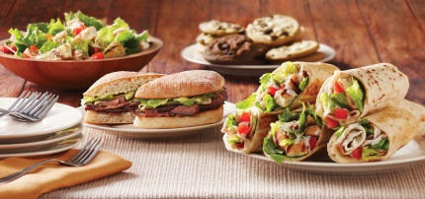
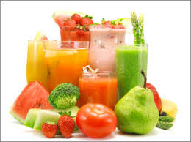

Beverage Sandwiches
- Delivery service are fast and always on time. Moreover, customers have no need to make a bundle of orders to get a delivery. (at least 3 products one order)
- Reasonable price and detailed nutrition information on the label of every product help customers to choose the best size for themselves.
- Colorful exciting decoration offers consumers feelings of relax and comfortable to release stress.

- What emotions are elicited by the brand either during or after the purchase
- Delightful, satisfied and trustful emotions and loving feelings are what the company tries to share with its customers during and after the purchase.

- What is the one word that best describes the brand
- Enjoyable

- What kind would your brand is
- Car: Smart car
+ Hybrid for green environment, small and bright color design for convenient youth style
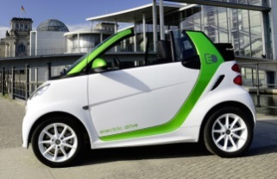

- Animal: squirrel (fast, live in forests and eat natural food)
- Instrument: Percussion (strong, active and young)

- Color: green (fresh and pure)
- Music group: One Direction (active and youth style of performance)

- What is important to consumers in the purchase of the product
- Consumers are provided with the high quality of organic beverage and sandwiches, promoting their health better every day.
- Be convenient and save time to order online at home or office with a fast delivery service.
- Display nutrition information in detail on the label in the packaging of take away and on the board menu at the store.

- PACKAGING
- The packaging consists of three sizes like the picture: small, medium and large
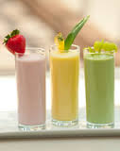
- Instead of Starbucks logo, we put our logo like the picture.
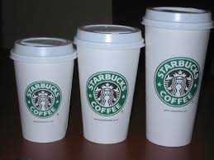

At the store. Take away

- This packaging is easy to use and convenient to take in hand going everywhere
- The container is light, cheap and can recycle that improves a green living environment.
- The color is still bright to capture customer’s attention and conveys enjoyable, fresh feelings.

- LABEL
- This label is attached on every product of take away
- In case, customers enjoy at the store, we have nutrition information next to each product on the board.

- CONSUMER PURCHASE PROCESS
- What problem is your product/service solving
Obesity is one of the most serious diseases which are threatening citizens’ health all over the world, particularly Americans who use fast food, cheeses and sweet cakes as their main menu. Moreover, the popularity of many bottled drinks with cheap prices such as cokes, energy water and fruit juices are attributed to American consumers’ diabetes. Therefore, Tropical Organic Garden has a good chance to develop when it brings American consumers beverage and sandwiches with 100% organic ingredients with reasonable prices, without artificial agents causing obese and diabetic problems.

- What is the recognizable need or want
For now the trend is emphasizing on health. People need and want their daily meals to be upgraded with the more quality and more nutrition. They are more likely to pay attention to the criteria of food and drinks they use every day. Understanding consumers’ need and want, Tropical Organic Garden gives American consumers a good opportunity to take care of their health by enjoying its products derived directly from nature. Especially, for busy customers Tropical Organic Garden provides a definitely fast delivery service with the convenience of online order.

- How is the information search conducted (internal/ external)
- Internal search: Most people think of Jamba Juice when it comes to fruit juices or smoothies because it is the most well-known brand in this industry.
- External search: Some customers might want to change their favor and try another brand name. According to online search, some popular other juice and smoothie brands are Naked, Bolthouse Farms and Odwalla. But all of these ones are refrigerated bottled juices.

- How does your consumer evaluate alternatives
Customers will compare the quality as well as price between fresh juices or smoothies of Jamba Juice and refrigerated bottled drinks of the others. Jamba Juice is a famous brand which has many stores across the U.S. Each store is often crowed, especially at the break-time. Here staff produces drinks in front of customers based on their requirements. Therefore, customers are more likely to trust in the brand name more than the others. Maybe Jamba Juice’s price is higher than the others, but customers appreciate its quality through the way it is serving them. For Naked, Bolthouse Farms and Odwalla, customers do not trust in them much due to their own refrigerated bottled serving. However, they offer customers cheap prices and convenience to buy everywhere in grocery stores without queue.

- What consumer attitudes can be influenced by your IMC
Tropical Organic Garden is going to set up IMC plans that emphasis on health care. The marketers give messages and marketing campaigns to encourage people to be aware of a better life through sources of healthy nutrition in organic food and beverage. The marketers try to change purchasing habit of Americans from frozen food and beverage to fresh and organic ones. As a result, people just only think of high quality food and beverage, particularly organic brand names such as Tropical Organic Garden. Moreover, in marketing plans the marketers also emphasis on the convenience of delivery service that customers have no need to make a bundle of orders (at least 3 orders). This service is friendly with all people, particularly target customers – always busy.

- What values about your brand do consumers hold.
- Prestige, quality and professional serving but friendly feelings.

- Define the set of personal values and how your IMC plan can integrate that value into creative.
- In addition to quality, healthy nutrition values, the shop also brings customers comfortable, fun and exciting feelings through fresh tastes and bright colorful decoration.
- The marketer will set up workshops of healthy nutrition information occasionally to guide people on how to live better through daily nutrition source control. The shop has more chances to get feedbacks from customers and introduce new products to customers. It also helps connect the brand name with customers, increasing repurchase decision.
- On holidays the shop celebrates a contest that encourages customers to decor drinks in the best performance.
- At the certain time, the shop will offer customers a free trip to farms where the shop gets its ingredients.

- TREND IN THE CONSUMER BUYING ENVIRONMENT.
- Age: the shop encourages all of ages to use fresh and organic food or beverage because it’s high quality of nutrition values. However, the shop pays more attention to the youth (student age to 40 years old) as its target customers. They are so busy that they do not have free time to do fresh drinks or sandwiches at home, as well as to queue line at stores such as Jamba Juice. The shop serves the high quality sandwiches and beverage with a fast delivery.
- Gender: the both male and female
- Income: middle to high income
- Lifestyle: focus on active, busy and enjoyable young people.

- CUSTOMERS
Tropical Organic Garden is a new company, so the shop does not have current and former customers.
- Potential customers
Firstly, people who pay much attention to health as well as the criteria of food and drinks they use every day. They have an eye on their ingredients carefully whenever they pick up something, for example, how much calories, protein, fat and sugar amounts.
Secondly, they are young people living in downtowns or working here. They are too much busy to take care of themselves well. They want to enjoy fresh healthy food and beverage but they do not have much time to do them at home. Therefore, they are more likely to buy but almost organic and healthy food and drinks are served at high-end restaurant outside the downtown without delivery service. Thus, it is not convenient to dine there in early morning for breakfasts or in a short break time for lunches, even they cannot also afford to dine there too often. For these reasons, Tropical Organic Garden is confident to satisfy them well with organic and fresh products as well as high quality. They are potential customers the shop wants to reach out.
- Competition
Competitors’ customers: Jamba Juice (big competitor)
It is the same characteristics as Tropical Organic Garden: the young people, middle class and upper middle class and they have healthy lifestyle – emphasis on health and want to enjoy high quality food and drinks (fresh and natural) with reasonable price. They have enjoyable, busy and fashionable lifestyle.
Some popular campaigns:
In 2014, Jamba is a proud sponsor of "Team Up for a Healthy America" in the fight against childhood obesity and encourages fans to join the Team Up community of celebrities, athletes,
and other leaders committed to getting kids active. Fans of Jamba Juice can find out offerings and promotions at the website.
Moreover, Jamba Juice also commit to many other communities as a community partner. For instance, it awards the grand prize of the 2014 "It's All About the Fruits and Veggies” to a school in the Sacramento to support schools through garden education and healthy beverage offerings.
The other one, Jamba Juice launches its "Pink Whirl" in-store donation campaign to help raise awareness for breast cancer and support the National Breast Cancer Foundation (NBCF) during the month of October, National Breast Cancer Awareness Month.
- The strategy: Build up the friendly brand image with local communities
+ Tactics: gives many supports to the communities that encourage the communities to have a healthier life through the ways of sponsorship, award grants and donations. This strategy gets the company closer to the community as well as improves the brand awareness and makes love the company more.
Another campaign is the contest, called “Blend In The Good,” asked people to upload videos of them dancing, to signify the good both inside and out of the drink. Jamba Juice teamed up with popular YouTube channel DanceOn to encourage fans to shake it to promote the health value of their new line of juices. They uploaded the choreographed entries on their YouTube channel and their webpage. The contest ended on August 31st, 2014. Prizes for the top three entries, selected by a panel of judges, include a trip to New York City in June, Los Angeles in July or San Francisco in August along with a $100 Jamba Juice gift card each.
- The strategy: Repositioning the brand name – empowering healthy nutrient beverage.
+ Tactics: rejuvenate the image by adding their new lines of juice and promote their healthy value with tasty, high-nutrient and low sugar ones. This is an impressing move in the strategy of Jamba Juice. Kevin O’Donnell, a brand consultant with Prophet, told Adweek that the chain’s
high-calorie, high hexose drinks were muddying its healthy image. As a result, this strategy helps the company satisfy the growing demand of health-conscious choices.

- Communication
The Firm’s current communications
For the young customers, Tropical Organic Garden will communicate its brand name on the website, attractive colorful graphics or posters in the downtown and in the colleges & universities. More especially is on social media such as Facebook, Twitter and YouTube. The shop tries to build up its fans through campaigns, trips and social activities. Moreover, the shop always reminds customers of its delivery service, one of the competitive advantages to compete with the big competitors.
+ Set up workshops of healthy nutrition information occasionally to guide people on how to live better through daily nutrition source control. The shop has more chances to get feedbacks from customers and introduce new products to customers. It also helps connect the brand name with customers, increase purchase decisions.
+ Celebrates some contests that encourage communities joining such as decoration contest of juices. The winner will show the best performance.
+ Offer customers a low- cost trip for potential customers and free trip for loyal customers to farms where the shop gets its ingredients.
+ Celebrate social activities in the local community - raising fund for healthy meals for children at poor countries such as South Africa, Cambodia.

The message being conveyed to current customers, potential customers
- The shop brings customers high quality products, diversity of tropical juice and smoothie flavors and 100% organic and fresh ingredients. The shop does not add any concentrated ingredients such as sugar, flavor and ice-cream. All of these products including beverage and sandwiches are totally from nature. (less ices)
- The shop tries to change customers’ belief and attitudes about health care in daily life. The shop conveys messages that encourage people to pay much attention to their health through daily meals as well as show them how much better their life when they eat and drink better.
- For busy customers, they have no need to worry any more for queuing in long line to wait for juices or smoothies in Jamba Juice stores. For now, let Tropical Organic Garden helps them with the fast delivery service. They just pick up a phone or log in the website to order what they want. The shop will satisfy them. This is a typical message the shop wants to convey to customers.
Although it is hard and take time to change the belief and attitude of someone, the health-conscious choices are increasing gradually through marketing campaigns the big competitors have been doing. The shop now can take advantage of this chance to do marketing for its products.
Group1 Group 2

- TARGET CUSTOMERS
- Demographics:
The shop encourages the all of ages but emphasis on the young group in the range of 25-29 (age). The second group consists of the businessmen and businesswomen in the range of 30 – 40 years old (age). They are successful middle and upper middle class (income).
- Psychographics
In the range of 25-29 ages (group): are active, fashionable, extrovert and independent. They love fresh colorful juices and smoothies, because it looks youth and trendy.
In the range of 30-40 ages (group): pay much attention to health care. They are willing to pay more to get high quality food and drinks. They are busy and do not want to queue in long line to wait for an order at Jamba Juice and they don’t have to make a bundle of orders to get delivery service.
- Geographic
- In the downtown of San Francisco

- Benefits
- Emphasis on health

- Usage
- Be more like to take away

- POSITIONING
- Price/quality
The shop wants customers to remember its products and service with high quality, 100% fresh and organic ingredients directly from the prestigious farms. However, its price is reasonable who workers can afford, and middle and upper middle class can afford to buy its products too often.

- Product Attributes
When it comes to Tropical Organic Garden, customers think of the benefits of its products and service brings them. That is fresh and delicious taste with the high quality which helps customers become healthy, younger and have soft skin. The shop’s decoration always helps customers relaxing and feels comfortable whenever stop by.

- MARKETING COMMUNICATION OBJECTIVES
- Develop brand awareness
This is a new shop in the market, so the shop’s IMC focuses on the brand awareness as an important step of the success. The shop wants people to know the new brand coming as well as competitive products and service.
- Change customer beliefs and attitudes
One of the first things the shop needs to do is the change of customer belief and attitudes. The shop’s IMC efforts want people to recognize the benefits of eating and drink better with fresh high quality products. Customers’ main menu is changed from fast food or bottle drinks to 100% organic ingredients from nature which are always better for healthy life.
- Encourage repeat purchase
This is one of the purposes all companies want to get. The shop tries to satisfy customers in every touch points to hope that they will come back again and again. The shop pays much attention to loyal customers and has many different promotions to encourage them to repeat purchase.

TARGET CUSTOMER DESCRIPTION
The target customers of the Tropical Organic Garden are the young group in the range of 22-29. The group of businessmen and businesswoman or white-collar people is in the range of 30 – 40 years old.
- In the range of 22-29 ages (group 1): they are active, creative, fashionable, extrovert and independent as well as be able to pay for themselves. Some of them have stable income and successful already. They love fresh colorful juices and smoothies, because it looks youth and trendy. In addition to tangible values such as quality, the shop also brings these customers intangible values that when the customers use the products, they can express their own characteristics: youth, active and generic.
- In the range of 30-40 ages (group 2): almost they are successful already and upper-middle class and pay much attention to health care. They are willing to pay more to get high quality food and drinks. They are busy and do not want to queue in long line to wait for an order at Jamba Juice and they don’t have to ask other people to make orders together to get delivery service. They can do work and enjoy their beverage & food at the same time at their desk.
Generally, the common things between group 1 and group 2 as the target customers are they live or work in the downtown of San Francisco. They believe in nutritional value of organic products that helps them healthier. They are willing to pay extra for high quality products and good service. They are middle-class and upper middle class and they are more likely to take away rather than in-store.

THE PICTURES OF TARGET CUSTOMERS

Tropical Organic Garden

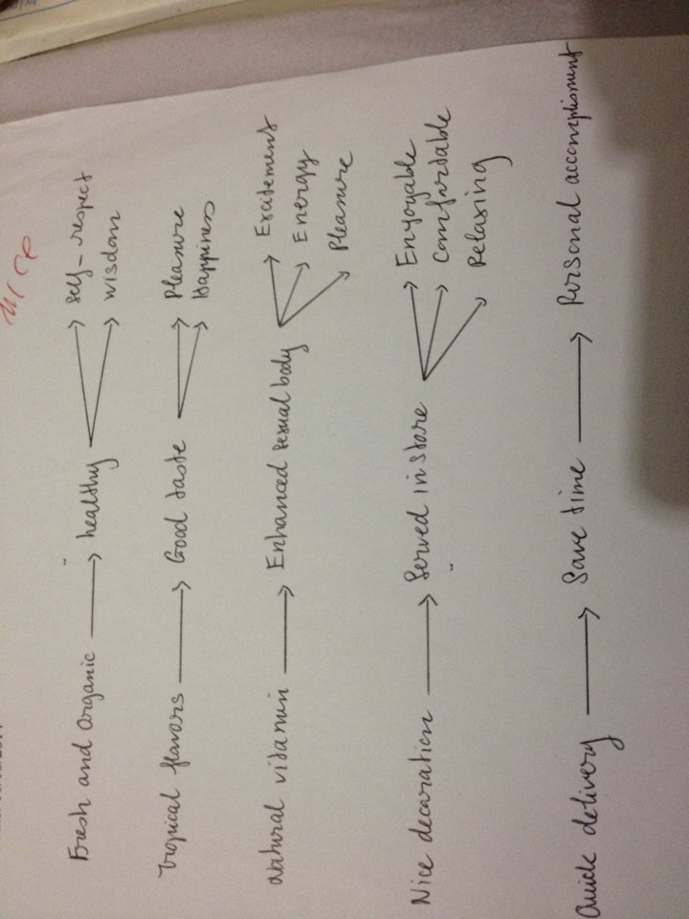
Products: Smoothies & Fruit Juices – Sandwiches (Organic ingredients)
Service: In store & Take away.

- ADVERTISING APPEAL
Tropical Organic Garden combines Sex and Emotion appeals for advertisings. Each of these appeals is more likely to guide customers to the feelings of happiness, health and full of energy whenever drinking fruit juices. On the bottom right corner of the advertisings, there are images of fresh colorful juice classes, along with the content (Unique Point Proposition– 100% organic ingredients) to encourage people to drink fruit juices daily for a wonderful life like features described in the ads.
Tagline: Live healthy for a wonderful life.
- The sex appeal shows off healthy ideal bodies which people wish to be. This appeal convinces them drinking fresh and organic fruit juices of Tropical Organic Garden so that their own body is able to become like that.
- Emotion appeal gives viewers the feelings of happiness, pleasure and satisfaction. This appeal arouses the imagination of a wonderful life when people live healthy through the use of fresh and organic fruit juices and meals.
- Sex appeal can capture viewers’ attention for its exciting features and Emotion appeal incorporates people with positive feelings. As a result, they help connect directly products’ benefits with personal values.
- Moreover, for the ads in television, Tropical Organic Garden can add music during the ads running. Music increases the retention of the information and brand name as well as intense the connections between emotions, memories and experiences.

- MESSAGE STRATEGY
Tropical Organic Garden chooses Cognitive (Preemptive) and Affective (emotional advertising) approaches for the message strategy.
- The shop will presents rational features that describe the main products’ attributes and benefits as the claims of health, pleasant tasting, low calories and natural vitamins customers can obtain by purchasing the products.

+ Preemptive: use the claim of superiority to prevent competition from making the same statements (“the best fresh for health”). The shop emphasizes on the unique points of the products are fresh and organic. Although other competitors provide customers with products from fruits, not all of them are fresh totally from nature and no one states it as a promise. Therefore, the shop takes the chance to become the one which states the advantage first.
+ Affective (emotional advertising): the shop wants to invoke feelings or emotions and match those feelings with the products and service. These emotions are trust, pleasure and happiness.
The ads presents a group of people or couples (men and women) in the arrange of 22 – 40 years old as the target customers, who are enjoying exciting and happy moments in life through the Sex appeal (healthy ideal bodies) and Emotion appeal (smiling faces) by using the fresh fruit juices every day. On the bottom right corner, the messages present the message “the best fresh for health – That’s Tropical Organic Garden”
- Some optional choices which the shop considers for its ads in the public. On the bottom right of corner of each ads contains the images of fresh juice classes and the messages mentioned above.

- EXECUTIONAL FRAMEWORK
The shop uses Slice of Life and Testimonials for its executional framework, but the shop is more likely to focus on Slice of Life as a main type. The shop offers customers solutions to the common problems nowadays which are obesity and diabetes and helps customers save purchasing time. The shop highlights the way its products and service can meet customers’ needs. (Healthy ingredients and quick delivery). Moreover, the shops use Testimonials from current customers to add the credibility of the brand name. The Testimonials will motivate purchasing decisions of potential customers.

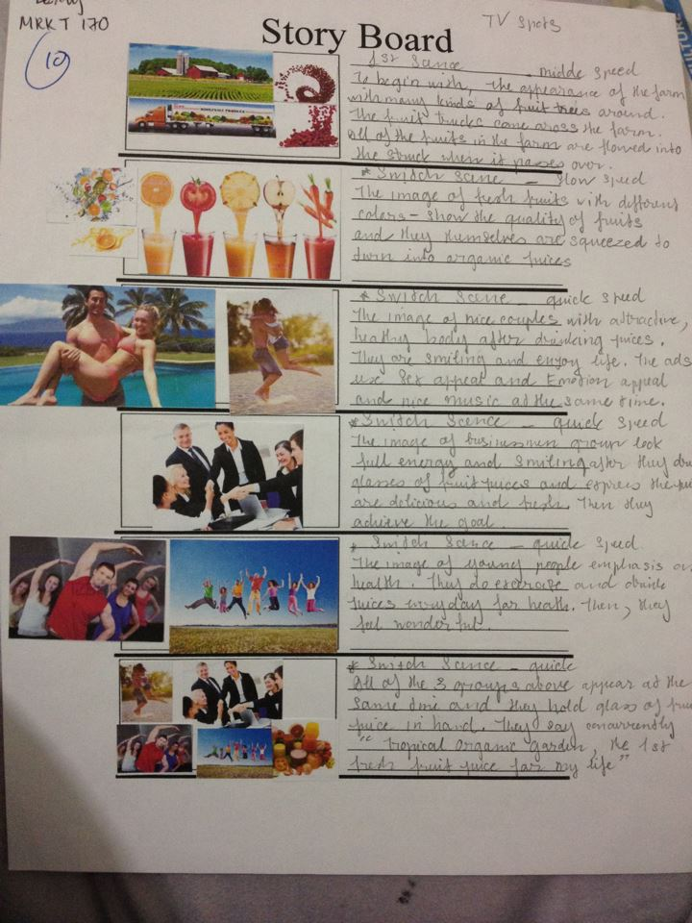

I. EXPERIENTIAL MARKETING
Tropical Organic Garden uses Experiential Marketing to help consumers experience the brand. The goal is to form a memorable and emotional connection between the consumer and the brand so that it may generate customer loyalty and influence purchase decision.
- Create a community campaign
It is described in the story board. The shop sets up a marketing campaign in the Union Square of San Francisco, a big modern city of the U.S where the target customers gather. The shop opens a contest that participants have to make mixed up juices or smoothies, and then decorate them in the most exciting way as much as they can. They have to do all of these things by themselves, even make electricity to run the blenders. The shop gives them a limit time to finish their products.
The process as following:
+ They choose the fruits to make juices or smoothies. The maximum is 5 ones (image no.3)
+ They ride the exercise bicycle to make electricity to run their blender (image no.4)
+ The move to the place to choose other ingredients for decoration (image no.5)
- The winner will get free one glass of juice or smoothie every day within 30 days.
- Moreover, the shop sets up a large area (image no.1 and no.2) so that other people can experience the brand. They get one free juice or smoothie and dance together with music played by the DJ in the music booth.
- The shop shows a big logo image, the poster of tagline “Live healthy for a wonderful life”. There are some big plastic samples of juice or smoothie bottles and glasses on sides
- The campaign will happen again at another big city as Los Angeles.

- The shop also tries to create Buzz Marketing by uploading images and information of these campaigns on the website and social media such as Facebook, Twitter and YouTube to encourage people to join, to share ideas and to discuss together.

- BUZZ MARKETING
- Celebrate the “Let’s do more beautiful everyday” program
- The program encourages people to join with the purpose of their body promote. There is limited number of participants (maximum 8 people), especially obese people are encouraged to join in the program.
- Firstly, they show off their appearance as they look daily.
- Within 45 days, they have to try hard to change their appearance to be more beautiful and attractive. They can do some methods, particularly doing exercise. The shop will provide them with free juices and smoothies every day to help their body and skin healthy. They can make up on face (women) and hair, even dress up as extra supports. At the end of the deadline, they are present again. The winner is the one who shows the examiners their surprising change in the most positive way.
- The winner gets the prize of 50% discounted promotion on any juice or smoothie deals within 1 year.
- After the program, the shop encourages the winner and participants share their ideas on social media (Facebook, YouTube, Twitter, Blog) about their challenging experiences during the period of the program. For instance, how they improved their body and how much difficult experiences they overcame to make their body look more attractive. Their feelings about the program as well as the juices and smoothies they used daily.
- The shop uploads the video of each participant in YouTube so that fans and people can keep track of the program. People can vote for the participant they love.

- The shop encourages people share the video as well as discuss about the program on social media.
- The program is celebrated per 3 months. It encourages people to do exercise and drink healthy juices every day to get healthy. The shop wants to link the healthy life with its products.
III. GUERRILLA MARKETING
The shop is a new business that had better use Guerrilla Marketing method to create excitement and involve interacting with customers. Moreover, it spends low-costs. The excitement will make customers interested in and remember the brand longer. It also improves the brand image. The shop can create the placement like the picture given. Instead of the Mc Donald cup, the shop displays the juice cup with the brand and logo printed. Moreover, on the face of the cup there is a button with the notice “Push to change color”. People can push on the button to change the color of the cup in random. Each color features the kind of juice or smoothie. It is more likely to attract people curiosity, especially in night.

- PRODUCT PLACEMENT
- Sponsor The Amazing Race America
No wonder, the Amazing Race America attracts a big number of viewers nationally. The participants experience many challenges in the period. On every race, they are provided free juices or smoothies. Therefore, when the shop sponsors this program there are many people to see the logo and the brand of Tropical Organic Garden on the streets and through TV and social media.

- Sponsor other sports programs such as marathon or charity programs to help obese patents and cancer patients.
All of the programs and campaigns emphasis on the interaction between health issues and products’ benefits. Moreover, the shop tries to create consumers’ experiences with the brand. As a result, the brand can build up its fans and communities and make consumers become loyal.

- COUPON
- The Tropical Organic Garden will release coupons inserted on flyers in early days of brand opening.
- The shop gives people the flyers on streets, especially gives out at companies and shopping malls in the downtown of San Francisco where are many potential and target customers.
- On the flyers shows off the new brand name opening, location address, logo and the information of promotion program such as time and discount in details. It looks like the picture following:
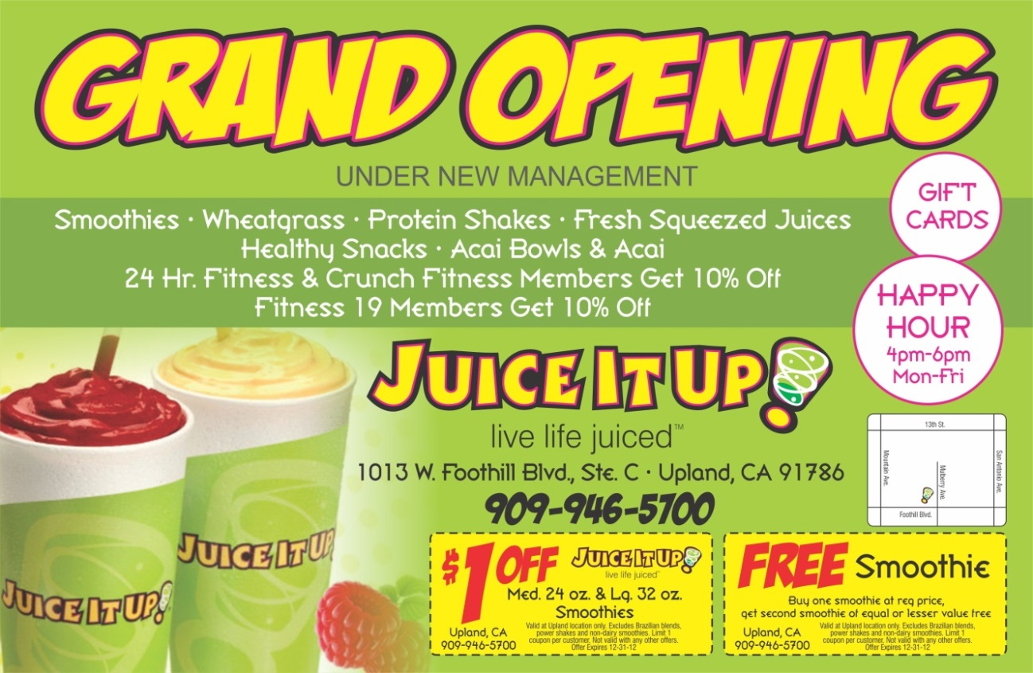

Moreover, the shop also encourage people to access to the website, then provide their personal information to login. After they login, the shop will send them email to confirm and show them the promotion code in email. When customers make order online, they type the promotion code, they will get the discount. Customers who buy in-store need to show the shop’s casher the code, they also get the discount as well.
- By this way, the shop will get the customers’ profile or at least their information such as email, address and cell phone. It is useful for the shop customizes the marketing program in future.
The loyal program
- For loyal customers or potential customers who buy a bundle of products at each order, the shop will give them a special coupon that discounts them 20 percent off next time.
- This program makes their customers feel they are special to the shop as well as the shop cares its loyal customers so much.

- CONTEST
It is described in the story board. The shop sets up a marketing campaign in the Union Square of San Francisco, a big modern city of the U.S where the target customers gather. The shop opens a contest that participants have to make mixed up juices or smoothies, and then decorate them in the most exciting way as much as they can. They have to do all of these things by themselves, even make electricity to run the blenders. The shop gives them a limit time to finish their products.
The process as following:
Step 1: They choose the fruits to make juices or smoothies. The maximum is 5 types Step 2: They ride the exercise bicycles to make electricity to run their blender or juicer. The quicker they ride, the faster blender or juicer run.
Step 3: They move to the place to choose other ingredients for decoration.
They have 20 minutes to finish their work.

- The winner will get free one glass of juice or smoothie every day within 30 days in store or at their door in house or company.
- The shop also tries to create Buzz Marketing by uploading images and information of these campaigns on the website and social media such as Facebook, Twitter and YouTube to encourage people to join, to share ideas and to discuss together.
- SAMPLING
Whenever the shop adds the new juices or smoothies to the menu, customers are encouraged to try the new ones. Customers buying in-store or getting orders online, they will get one free very small cup of the new one. The flavors and information of ingredients are described on the cup. Moreover, the shop will notify its fans and communities on social media such as Facebook, Twitter and YouTube. The shop stimulates them to share their ideas about the new ones.
- Time for getting free the new one is 30 days since the day the shop introduces the new one.

SPONSORSHIP
- Sponsor The Amazing Race America
No wonder, the Amazing Race America attracts a big number of viewers nationally. The participants experience many challenges in the period. On every race, they are provided free juices or smoothies. When the shop sponsors this program there are many people to see the logo and the brand of Tropical Organic Garden on the streets and through TV and social media.
- Sponsor The Breast Cancer Walk - The San Francisco Marathon
- Sponsor some sports contests for student communities: at colleges and universities in San Francisco to approach target customers (young groups). It looks like Jamba Juice did.
- All of the activities that the shops sponsor are linked with health issues. This way promotes the close connection between the shop’s products and health. Whenever people think of healthy beverage and food, they can remember the brand name Tropical Organic Garden as the top choice.
