THE COMBINATIONS

A. BRANDING (THE COMBINATIONS)
BRAND CLARITY
1. The Combinations is the newest type of bars where we bring to single people the opportunity to find love with someone that share the same taste as them, starting with the drink.
BRAND PURPOSE
2. The Combinations is offering to its customers a true social experience, where they can actually talk to others in person instead of on their phones (perhaps through dating apps). We believe that people need and want more interactions in the real life. Love can be found online but how great it is to have the possibility to share looks, smiles, and laughs. That is the experience we want our customers will have; interact in person, share tastes and interests in life.
BRAND VISION
3. We do understand how difficult it can be, especially if a person is shy and that’s why we offer a cozy, romantic atmosphere; to make our customers as comfortable as they can. Drinks are also here to help people relaxing. We will offer a very exclusive list of cocktails (eight) to be sure that our customers will “match” with each other. The Combinations is focus on its customers welfare and comfort.
BRAND MASTER PLAN
4. We offer to our customers a unique experience, a safe space where they can feel special and privileged. Our bartenders are professionals, the best in their field and have a lot of experience. Cocktails change every three months and have to be approved by our team first. Each cocktail has its own taste (sweet, salty, bitter, sour, spicy, unami, metallic and coolness). The Combinations rises the quality standard of drinking out for a fair price value, pushing boundaries and set new frontiers. In addition, we offer a cozy, fancy, and romantic atmosphere. Inside the bar customers find cozy black leather fauteuils, small dark wood tables with a candle on every table, a big chandelier in the middle of the place with a beautiful tailor-made bar. We have glasses adapted for each drink and also a background music playing songs without lyrics.

BRAND CREATIVE BRIEF
5. The Combinations in the new trendy bar with the mission of bringing people back together, get to know each other over a drink and sharing same tastes and interests in life.
After the failure of speed-dating bars- because of the limit of time and lack of conversation, and the failure of dating apps- because the lack of trust from users, The Combinations is the new way for people to find true love. However, unlike those two failures, we, at The Combination, believe that to find love, people need time and something in common to start an interesting conversation.
We give to our customers the perfect atmosphere for them to be comfortable enough to engage a conversation with someone else. The inside of the bar will have cozy black leather fauteuils, small dark wood tables with a candle on every table, a big chandelier in the middle of the place with a beautiful tailor-made bar. Because we are offering an exclusive list of eight cocktails, each of them with a very specific taste, our customers feel special and valorized.
BRAND STORY
6. The Combinations was conceived when the owner, Marie, got tired of using online dating apps and decided to go outside, to meet new people in bars. She met a man one night in a bar and they talked all night about different alcohol taste, such as beers, wines, liquors and cocktails. She went back home and started to think about the great moment she had. She thought about people who don’t usually go out by themselves because they are shy but also don’t want to use online dating because they think that is not a good way to find their soulmate. A few days after, the idea of The Combinations came out by itself.
In this case, the customer’s pain is that they are single, want to find love but in a traditional way, although they are shy and don’t want to go to a bar by themselves. We, at The Combinations, offers the possibility for them to be in an environment where everyone is here for the same purpose and can feel more comfortable to engage a conversation.

B. BUILD THREE CUSTOMER PERSONAS FOR YOUR BRAND
Priorities
- Go out with friends
- Her appearance
- Money
- Find the newest trend
- Fashion
- Be popular

Digital life
- WatchYouTube
- Fan of HBO
- Not very active on Instagram
- Is on Facebook
- Is on Rebbit
- Loves technology in general
Priorities
- Work
- Save money
- Buy a house
- Find time for social life
- Willing to settle down
- Go out with friends
- Wants to have a family

The tech guy
Lifestyle
- 25-35years old
- Software engineer
- Live in the city
- Bachelor or Master
- Workaholic
- Single
- No kids
- Income $100k
Digital life
- Super active on Instagram
- Active on Snapchat
- Watches tutos on YouTube
- Not on Facebook
- On TikTok
The extrovert woman
Lifestyle
- 25-30years old
- Salesperson
- Live in the city
- College degree
- Single
- No kids
- Income $30k
Habits & Hobbies
- Social media
- Loves to go out
- Goes to the gym
- Live with her bestfriend
- Doesn’t cook
- Manicure/pedicure every 3weeks
- Puts makeup everyday
The shy woman
Lifestyle
- 23-30years old
- Live or commute
in the city
- Bachelor degree
- Likes her job
- Single
- No kids
- Income $60k
Priorities
- Her peace, happiness
- Her cat
- Makes everyone happy
- Help her parents
- Work
- Paying her student loan
Digital life
- Loves Pinterest
- Forum about books
- Order things online
- Is on Instagram and Facebook but not really active
- Not on Snapchat
Habits & Hobbies
- The new Iphone
- Likes video games
- Drinks with friends
- Live by himself
- Loves movies/tv shows
- Likes hiking
- No pets
- Doesn’t cook
Habits & Hobbies
- Likes yoga
- Plays with her cat
- Has a roommate
- Loves to read
- Go out sometimes with a few friends
- Drinks tea
- Likes to cook

C. CREATE A MOOD BOARD
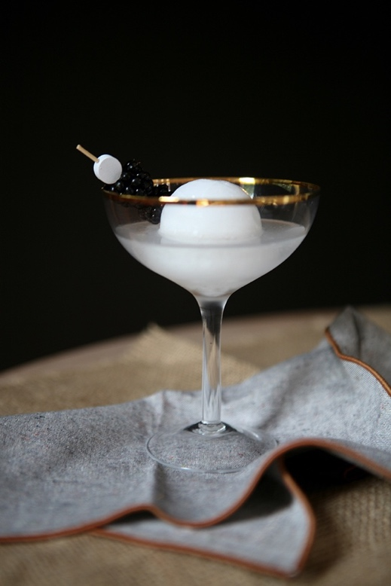
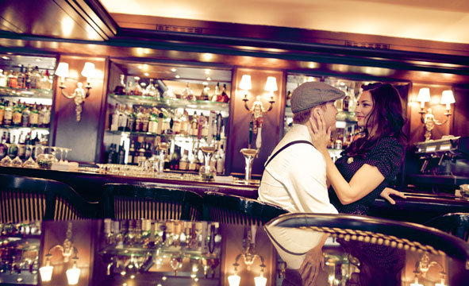
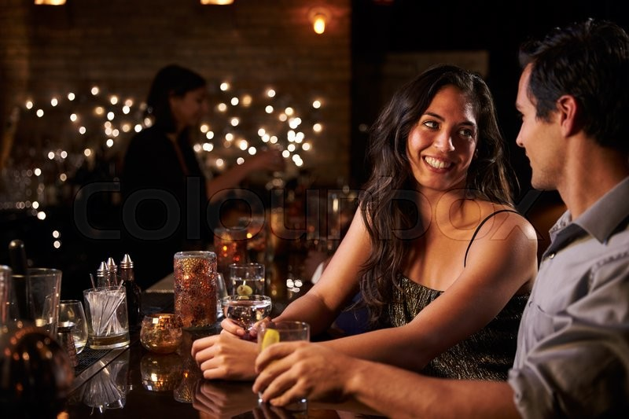
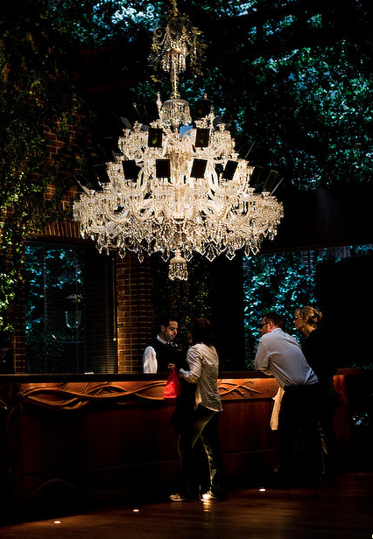

D. COMPLETE BELOW ABOUT YOUR BRAND

- My brand makes people feel loved
- If a loyal customer described my brand in one word, it would be intimated
- If a potential customer described my brand in one word, it would be sophisticated
- Interacting with my brand encourages people to socialize
- Two words that describe the mission and purpose of my brand are:
relationship and trust
- What is your company’s mission and vision statements, if you have them, to choose these words.
- Right now, my brand is new, authentic & romantic
- I want my brand to be reliable, durable & refined
- I don’t want my brand to be just a trend

TONE OF VOICE DIMENSION
Funny --------------------------------------------------------------|---------------------------------Serious
Enthusiastic -------------------|-------------------------------------------------------------Matter-of-fact
Respectful ---------|------------------------------------------------------------------------------Irreverent
Formal ------------------------------|----------------------------------------------------------------- Casual

E. SOCIAL MEDIA AUDIT

