Research Paper #4 – Febreze

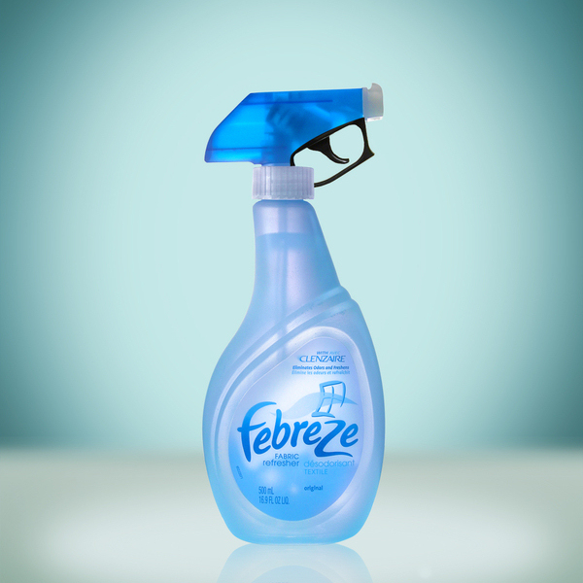

One of Procter & Gamble’s fastest growing products is Febreze. The product targets individuals who do not like washing laundry and has been positioned by P&G as an alternative method of completing this chore. An ideal target market would seem to be the 18 million college students in the United States. With busy class schedules, work, and social events, they may believe they do not have enough time to do laundry. For jeans and other clothes that are not quite dirty yet, Febreze offers the chance to “refresh” the clothes and kill any possible odors. John Paquin, EVP at the advertising agency WPP Grey Worldwide, which handles the Febreze account states that “washing is not a convenient part of the lifestyle at college.” He also recognizes that “mainstream media buys (such as TV) are not effective for the 18- to- 22 old.”
- Describe the college student you are targeting. Give a day in the life scenario.
  - Meet Sam…
- Identify what media you would use to reach 18 – 22 year-old college students. Explain the reasoning for each of the media selected.
- Design in detail an integrated campaign for Febreze aimed at the college demographic. Where would you place this ad(s)? Why?
- Consider the media you will use carefully TV, radio, print, social media, alternative media, sales promotions, sponsorships etc. Explain how each media integrates with the other to create a cohesive campaign.
- Pull out the color pencils and draw your visuals across each media

