MRKT 170
Advertising and Integrated Marketing Communication
website: ccsfmarketing.com

COURSE: MRKT 170: Fundamentals of Advertising
LOCATION: Cloud 102
CRN 71246 001
DAYS/TIMES: Tu Th 11:10 AM – 12:25 PM
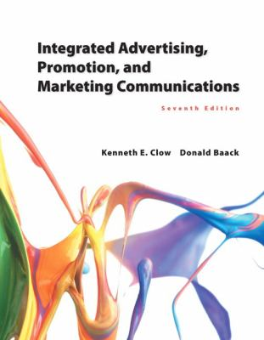
INSTRUCTOR: Mrs. Marilyn Goodman
OFFICE HOURS: Email: to schedule appointment
EMAIL ADDRESS: mgoodman@ccsf.edu
TEXTBOOK: Integrated Advertising, Promotion, and Marketing Communications (7th edition)
Clow Baack
ISBN-13: 9780133866339
ISBN: 0133866335
Edition: 7
Publication Date: 2015
Publisher: Prentice Hall

Course Description
This course provides an introduction to Advertising. Prerequisites: none.

COURSE OBJECTIVE
This course provides students an opportunity to gain an understanding of advertising and other mass communications marketing practices: common business activities and terminology, perspectives applied when taking the optimal approach to decisions, plus descriptions and rationales of common practices (which are often far from optimal). The class itself places emphasis on developing students' abilities to express their analysis and recommendations in class discussion, essay exams and written assignments.

The greatest difficulty for students in this class is shifting perceptual focus. You can no longer think as if you are part of the audience (as you do when you watch television commercials or read magazines), but instead, as if you are the creators of communications strategies. And you must put aside your personal tastes. Since not all audience members (if any) are people like you, advertising strategy and tactics must be assessed in terms of what a target audience might perceive, not in terms of what appeals to you. This is being realistic: in business, people preparing advertising, publicity and sales promotion strategy and tactics are seldom members of the target audience and strategy desirability must be judged in terms of what a target audience might like, dislike or understand. And this also means we will be covering some topic areas and using examples that you might find offensive, such as sexual appeals, or media vehicles whose audiences are people whose lifestyles or values are not the same as yours.

This course will be divided into five parts:
Part 1 – The IMC Foundation
- Integrated Marketing Communications
- Corporate Image and Brand Management
- Buyers Behavior
- Promotion Opportunity Analysis
Part 2 – IMC Advertising Tools
- Advertising Management
- Advertising Design: Theoretical Frameworks and Type of Appeals
- Advertising Design: Message Strategies and Executional Frameworks
Part 3 – IMC Media Tools
- Traditional Media Channels
- E-active Marketing
- Alternative Marketing
Part 4 – IMC Promotional Tools
- Database and Direct Response Marketing
- Sales Promotions
- Public Relations Sponsorship Programs
Part 5 – IMC Ethics, Regulation and Evaluation
- Regulations and Ethical Concerns
- Evaluating and Integrated Marketing Program

Methods of Learning
A variety of techniques will be used to enhance your learning for this course. These include lecture, discussion, debates, exams, video cases, in-class group activities, out-of-class individual assignments, and Internet research. You are expected to come to every session having completed your reading and/or other assignments. Bring your book to class every time. You will be using it.

Course Evaluation
You will have several opportunities to demonstrate your knowledge and understanding of the principles taught in this course. Though much of the learning is actually achieved in-class, you are expected to complete certain assignments before class and to turn in outside assignments on time.

Exams (4) 200 points
Research Papers (4) 200 points
Total 400 points

400 – 360 A
359 – 320 B
319 – 280 C
279 – 240 D
239 below F

The grading scale for course grades will be 90% and above: A, 80% to 90%: B, 70% to 80%: C, 60% to 70%: D, and less than 60%: F.

Attendance and Course Completion
Four absences or lack of satisfactory completion of assignments may result in your being dropped from the class or receiving an unsatisfactory grade.
Failure to hand in the first paper will result in a drop.
Failure to pass the first exam will result in a drop.

Please turn off and put away (out of site) all cell phones. Do not text or leave class to take a phone call.

All homework must be typed and submitted prior to class starting.
There will be no make-up exams given.
There will no late research paper assignments accepted. (please don’t ask)
Let me know if you need any accommodations (I’ll work with you to make sure you are successful)

