MRKT 122
Professional Selling
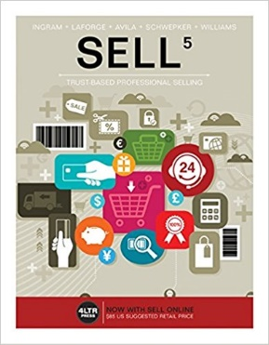
COURSE: MRKT 122: Professional Selling
LOCATION: BATL 349
CRN 31014 001
DAYS/TIMES: Tu Th 12:40 PM – 1:55 PM
INSTRUCTOR: Mrs. Marilyn Goodman
OFFICE LOCATION/HOURS: Email: to schedule appointment
EMAIL ADDRESS: mgoodman@ccsf.edu
TEXTBOOK: Sell 5 (5th edition)
Ingram, LaForge, Avila, Schwepker, Williams
ISBN-13: 978-1-305-66209-4
ISBN-10: 1-305-6629-1
Edition: 5
Publisher: Cengage

Course Description
This course provides an introduction to professional selling. Prerequisites: none.

COURSE OBJECTIVE
This course provides students an opportunity to gain an understanding of professional selling and covers professional selling practices and philosophies at an introductory level. Personal selling skills including developing and qualifying prospects, creating a sales presentation, closing techniques, and servicing the sales will be covered for business to business sales. Sales ethics, account relationship management, and basic professional networking will also be included. This course will require a lot of class participation, practice role playing, oral presentations, and critiquing fellow students’ various sales presentations.

Students examine an overall analysis of the professional selling function and gain insight into the role of personal selling in marketing and society and its applications within organizations. Topics include being a professional salesperson; knowing your product; finding customers; presenting successfully; closing sales; and managing and being managed.

This course will be divided into ten parts:
- Overview of Personal Selling
- Building Trust and Sales Ethics
- Understanding Buyers
- Communication Skills
- Strategic Prospecting and preparing for Sales Dialogue
- Planning Sales Dialogues and presentations
- Sales Dialogue: Creating and Communicating Value
- Addressing Concerns and Earning Commitment
- Expanding Customer Relationships
- Adding Value: Self-leadership and Teamwork

Methods of Learning
A variety of techniques will be used to enhance your learning for this course. These include lecture, discussion, debates, exams, video cases, in-class group activities, out-of-class individual assignments, and Internet research. You are expected to come to every session having completed your reading and/or other assignments. Bring your book to class every time. You will be using it.

Course Evaluation
You will have several opportunities to demonstrate your knowledge and understanding of the principles taught in this course. Though much of the learning is actually achieved in-class, you are expected to complete certain assignments before class and to turn in outside assignments on time.

Exams (3) 150 points
Class participation 50 points
Research Papers/Assignments (4) 200 points
Total 400 points

400 – 360 A
359 – 320 B
319 – 280 C
279 – 240 D
239 below F

The grading scale for course grades will be 90% and above: A, 80% to 90%: B, 70% to 80%: C, 60% to 70%: D, and less than 60%: F.

Attendance and Course Completion
Four absences or lack of satisfactory completion of assignments may result in your being dropped from the class or receiving an unsatisfactory grade.

Please turn off and put away (out of site) all cell phones. Do not text or leave class to take a phone call.

All homework must be typed and submitted prior to class starting.
There will be no make-up exams given.
There will no late research paper assignments accepted. (please don’t ask)
Let me know if you need any accommodations (I’ll work with you to make sure you are successful)

