RESEARCH ASSIGNMENT 3: SALES DIALOGUE TEMPLATE
- Describe in detail the product/service you are selling.
  - What can you tell us about this product/service?
  - What are the specifications of the product/service?
  - What features does it have?
  - How does it work?
  - How much does it cost?
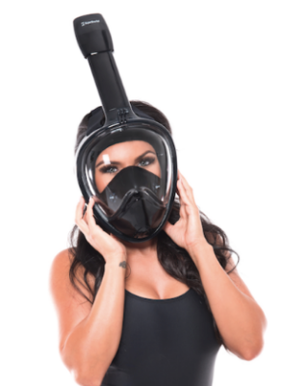
The SuperSnorkel is a full-face mask that allows you to breathe through either your nose or mouth while snorkeling, eliminating the discomfort of a mouthpiece. Our reverse-flow technology keeps water out and prevents you from getting a mouthful. Especially good for nervous or inexperienced men, women and youth.
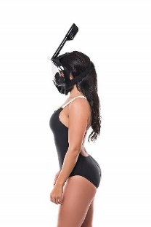
This clear and seamless mask allows your customers to enjoy the water and wildlife with a panoramic 180-degree view. Shatter-proof polycarbonate lens. The best dry snorkel set to go with your vest and fins. No Mask is completely fog proof, warm body heat and colder water temperature can create fogging in any mask. SuperSnorkel has included a premium anti fog spray Fog-X for use during these conditions. The fog resistant design pushes air away from your face, leaving you with a clear view of the wildlife. The silicone edging seals water out, and the one-way drain technology pulls any extra water away when tilted. Clients don’t struggle to enjoy their snorkeling experience - soft, adjustable straps make it quick and easy to get the fit and comfort just right. Even works with facial hair!
GoPro-ready with a special camera mount attachment so your clients never miss a photo opportunity fumbling with your camera. Snorkel and mask come with a carrying bag for travel. The SuperSnorkel retails for $39.99 and can rent for $9.00 per snorkel trip.
- Who you are selling it to?
I will be selling the SuperSnorkel to a chain of Hotels in Hawaii that operate snorkeling excursions to their customers staying at the hotel or booking private snorkeling trips. The SuperSnorkel will be part of their equipment rental. Kauai, Big Island & Maui snorkel rentals are one of the most affordable ways to have fun in Hawaii! Almost anywhere you go on the island, there is great snorkeling within minutes. The best part is that almost anyone of any age can enjoy this sport. In order to make the most of your time snorkeling in Hawaii, it is important to find the snorkel gear that is best for you.

- Customer Value Proposition: Write a brief statement of how you will add value to the prospect’s (individual or business) by meeting a need or providing an opportunity by answering questions below.
  - The primary reason that scuba resorts would use the SuperSnorkel is to generate revenue for the resort by offering a mask that is easy to use for anyone of all ages.
  - The key three benefit(s) likely to be most important to the specific customer who is the audience for this presentation.
    - Easy to use saving resort staff time adjusting for fit and comfort
    - No fogging or filling up allowing customers an excellent snorkel experience
    - More comfort, less adjustment for customers to enjoy their experience right away
    - Perfect photo opportunities with less lens obstruction allowing customers to capture beautiful underwater life
  - Value Proposition: The SuperSnorkel can improve your hotel chain snorkeling excursion revenue by getting your clients into the water faster, with more comfort and ease of use to enjoy their snorkeling experience and keep them coming back again and again.

- Linking Buying Motives to Benefits and Reinforcing Benefits: This section will address the buying motives of you customer who will be involved in the sales call.
  - Complete the following Sales Dialogue Template section.
6 Buying Motives: what is most important to the prospect in making a purchase decision  Rational motives (3)  Emotional motives (3) | Specific Benefits Matched to Buying Motives: Benefits to be stressed are arranged in priority order | Information needed to support claims for each benefit | Where appropriate, methods for reinforcing verbal content (sales aids, visual & Electronic materials, testimonials, supporting claims
- Profitability | - Easy to fit, save time – more clients in the water, higher turnover | - Number of clients the snorkel can service faster because of ease of use, explanation and adjustment  - Numbers from sale to rental | - Calculator that plugs in profitability  - Charts  - Current site rentals w/and wo SuperSnorkel
- Quality | - Builds trust with customers, safety in water, perceived professional company | - Zero accident reports, years with existing snorkeling resorts, snorkeling trip company of the year for past 3 years | - Physical materials used (prop)
- Service | Assurance of back end sales support, sales person to call, equipment repairs | - Service guarantees, mask warrantees, designated service representative | - Service guarantee
- Comfort & Convenience | Less adjustments in water, more time to enjoy, ease of use, no fogging, clear view | - Materials used, ease of assembly and fit  - % time spend more in the water | - Demonstration  - Customer testimonials  - Speed to teach customers how to use
- Entertainment | Photo opps for clients, greater experience, refer friends | - Lens material  - Visibility radius  - Avg number of pictures taken while snorkeling  - Picture quality | - Pictures from clients
- Pride of ownership | Self-actualization, owning best equipment, best offerings for clients | - Transfer of product reputation  - Growing business  - Competitive advantage | - Company service awards

